DIPLOMA SUPPLEMENT
This Diploma Supplement follows the model developed by the European Commission, Council of Europe and UNESCO/CEPES. The purpose of the supplement is to provide sufficient independent data to promote the international 'transparency' and fair academic and professional recognition of qualifications (diplomas, degrees, certificates, etc.). It is designed to provide a description of the nature, level, context, content and status of the studies that were pursued and successfully completed by the individual named on the original qualification to which this supplement is appended. It should be free from any value judgements, equivalence statements or suggestions about recognition. Information in all eight sections should be provided. Where information is not provided, an explanation should give the reason why.
- INFORMATION IDENTIFYING THE HOLDER OF THE QUALIFICATION
  - Family Name(s):
  - Given Name(s):
  - Date of birth (day/month/year):
  - Nationality:
  - Identity Card/Passport Number:
Number:
  - Student Identification Code:
- INFORMATION IDENTIFYING THE QUALIFICATION
  - Name of qualification and title conferred:

  - Main field of study for the qualification:
  - Name and status of awarding institution (in original language):
,
  - Name and status of the institution that administers the studies (in original language):
,
  - Language(s) of instruction and examination:
- INFORMATION ON THE LEVEL OF THE QUALIFICATION
  - Level of qualification:
  - Official length of programme:
years / semesters / weeks of study per year / ECTS
  - Access requirements:
See section 8.

- INFORMATION ON THE CONTENTS AND RESULTS GAINED
  - Mode of study:
Full-time.
  - Programme requirements:
The consists of ECTS and doesn't offer any specialization area.
  - Programme requirements:
The consists of ECTS and offers specialization areas: .

The organization, curricular structure and the graduation study plan are published in Diário da República at .
  - Programme Details:
Is exempted from studies
Execution  Year | Curricular Unit | Type  Compulsory  Optional  Extra-curricular | Duration  Annual  Semester | ECTS  Credits | Grades |  | Obs.  (*)
 |  |  |  |  | 0-20  Scale | ECTS  A-E | Obs.  (*)
executionYear | name | type | duration | ectsCreditsForCurriculum | gradeValue | ectsScale | academicUnitId
(*)
identifier | name

  - Classification system:
Is exempted from studies
It is necessary to achieve a minimum grade of 10 in each curricular unit for approval.
Considering the previous academic years to take the degree, the overall classification results of this degree graduates are distributed according to the national grading scale, as well as, to its equivalent in the ECTS Grading Scale stated below:
National Grade | 10 | 11 | 12 | 13 | 14 | 15 | 16 | 17 | 18 | 19 | 20
% | percentage
ECTS Grade | ects

  - Overall classification of the qualification:
Is exempted from studies
values
(ECTS)
  - Thesis classification

- INFORMATION ON THE FUNCTION OF THE QUALIFICATION
  - Access to further study:
Not Applicable
  - Access to further study:
The qualification of degree grants access to postgraduate studies, according to the terms described in section 8.
  - Professional status (if applicable):
Not Applicable
  - Professional status (if applicable):
The use of the professional title of requires a qualifying request to .
- ADDITIONAL INFORMATION
  - Additional Information:
No recognised extra curricular activity.
activity
  - Further information sources:
www.ulisboa.pt, www.tecnico.ulisboa.pt, www.naricportugal.pt/naric/
- CERTIFICATION OF THE SUPPLEMENT
  - Date (day/month/year): 05/03/2015
  - Signature:
  - Capacity: President of
  - Official stamp or seal
- INFORMATION ON THE PORTUGUESE HIGHER EDUCATION SYSTEM
The description of the Portuguese Higher Education System, officially provided by NARIC (National Academic Recognition Information Centres) is the following:

The Framework Law on the Education System (Law nr. 46/86, dated 14 October 1986, further amended by Laws nr.115/97, dated 19 September and nr. 49/2005, dated 30 August) establishes the general legal framework of the Education System.
According to this Law, the educational system comprises three levels: basic, secondary and higher education. Basic Education is universal, compulsory and tuition free and comprises three cycles, the first cycle lasts for four years, the second lasts for two years and the third lasts for three years. Pre-school education is optional and is for children between the ages of 3 and the age of entering basic education.
Secondary education is not compulsory and it comprises a 3 - year cycle (corresponding to 10th, 11th and 12th year of schooling).
HIGHER EDUCATION STRUCTURE
Higher Education includes university and polytechnic education.
University education is offered by public, private and cooperative university institutions and polytechnic education is offered by public, private and cooperative non-university institutions.
Private higher education institutions must be subject to the previous recognition of the Ministry of Education and Science.
LICENCIADO DEGREE
Both university and polytechnic institutions confer the degree of licenciado (bachelor). In polytechnic education, the cycle of studies that leads to the degree of licenciado has 180 credits and a normal length of six curricular semesters of students' work. In certain cases namely those covered by internal legislation or by European legislation, the cycle of studies can have up to 240 credits with a normal length of up to seven or eight curricular semesters of students' work.
In university education, the cycle of studies that leads to the degree of licenciado has from 180 to 240 credits and a normal length between six to eight curricular semesters of students' work.
In the 1st cycle of studies, the degree of licenciado is conferred to those that, after concluding all the curricular units that integrate the study programme of the licenciatura course, have obtained the established number of credits.

MESTRE DEGREE
Both university and polytechnic institutions confer the degree of mestre (master). The cycle of studies that leads to the degree of mestre has from 90 to 120 credits and a normal length of between three to four curricular semesters of students' work. In polytechnic education, the cycle of studies that leads to the mestre degree must ensure predominantly that the student acquires a professional specialization.
In university education, the cycle of studies that leads to the mestre degree must ensure that the student acquires an academic specialization resorting to research, innovation or expansion of professional competences. In university education, the mestre degree may also be conferred after an integrated cycle of studies, with 300 to 360 credits and a normal length of 10 to 12 curricular semesters of students' work, in cases for which the access to the practice of a certain professional activity depends on that length of time established by legal EU standards or resulting from a stable practice consolidated in the European Union. In this cycle of studies the degree of licenciado is conferred to those who have obtained 180 credits corresponding to the first six semesters of work.
The degree of mestre is conferred to those that, after concluding all the curricular units that integrate the study programme of the mestrado course, have obtained the established number of credits, as well as successfully defended in public their dissertation, their project work or their traineeship report.

DOUTOR DEGREE
The Doutor (doctor) degree is only conferred by university institutions. The degree of Doutor is conferred to those that, after concluding all the curricular units that integrate the study programme of the Doutoramento (doctorate) course have successfully defended their thesis in the public act.
ACCESS CONDITIONS
GENERAL REGIME RO ACCEDE TO HIGHER EDUCATION
National and foreign students wishing to apply through the general regime to the first cycle of studies must fulfil the following conditions:
-Have successfully completed a secondary course or a national or foreign qualification legally equivalent;
-Have set for the entrance examinations required for the degree programme the student wishes to attend and get the minimal mark required (There are higher education institutions that accept foreign tests or exams);
-Have fulfilled the prerequisites for the higher education course the student wishes to attend, if required.

SPECIAL CONDITIONS
Besides the regime geral (general regime), there are special conditions for top level athletes, Portuguese citizens on an official mission abroad, national or foreign staff in diplomatic mission, permanent staff of the Portuguese Armed Forces and scholarship holders within the framework of cooperation agreements signed by Portugal.
SPECIAL APPLICATIONS
Besides the general regime and the special conditions there are also special applications for candidates with certain specific qualifications thus allowing new publics to accede to higher education in a perspective of lifelong learning, namely:
-Applicants over 23 years old who have passed a especial exam for assessing their capacity to accede to higher education;
-Holders of a specialization technological course.
Admission to higher education institutions is subject to numerus clausus.

ADMISSION TO 2ND CYCLE OF STUDIES
Those who meet the following conditions may apply to the cycle of studies that leads to the mestre degree:
-Holders of the licenciado degree or legal equivalent;
-Holders of a foreign academic degree conferred following a 1st cycle of studies organized according to the principles of the Bologna Process by a State that has subscribed this Process;
-Holders of an academic, scientific or professional curriculum vitae that is recognized as attesting the capacity to carry out this cycle of studies by the statutorily competent scientific body of the higher education institution to which they wish to be admitted.

ADMISSION TO 3RD CYCLE OF STUDIES
Those who meet the following conditions may apply to the cycle of studies that leads to the doutor (doctor) degree:
-Holders of the mestre (master) degree or legal equivalent;
-Holders of a licenciado degree who have a particularly relevant academic or scientific curriculum vitae that is recognized as attesting the capacity to carry out this cycle of studies by the statutorily competent scientific body of the higher education institution to which they wish to be admitted; holders of an academic, scientific or professional curriculum vitae that is recognized as attesting the capacity to carry out this cycle of studies by the statutorily competent scientific body of the higher education institution to which they wish to be admitted.

CLASSIFICATION SYSTEM
The degrees of licenciado and mestre shall have a final classification between 10 and 20 on a numerical scale of 0 to 20, as well as its equivalent in the European scale of comparability of classifications. The academic degree of doutor is assigned a final classification pursuant to the regulating standards approved by the university that confers it.
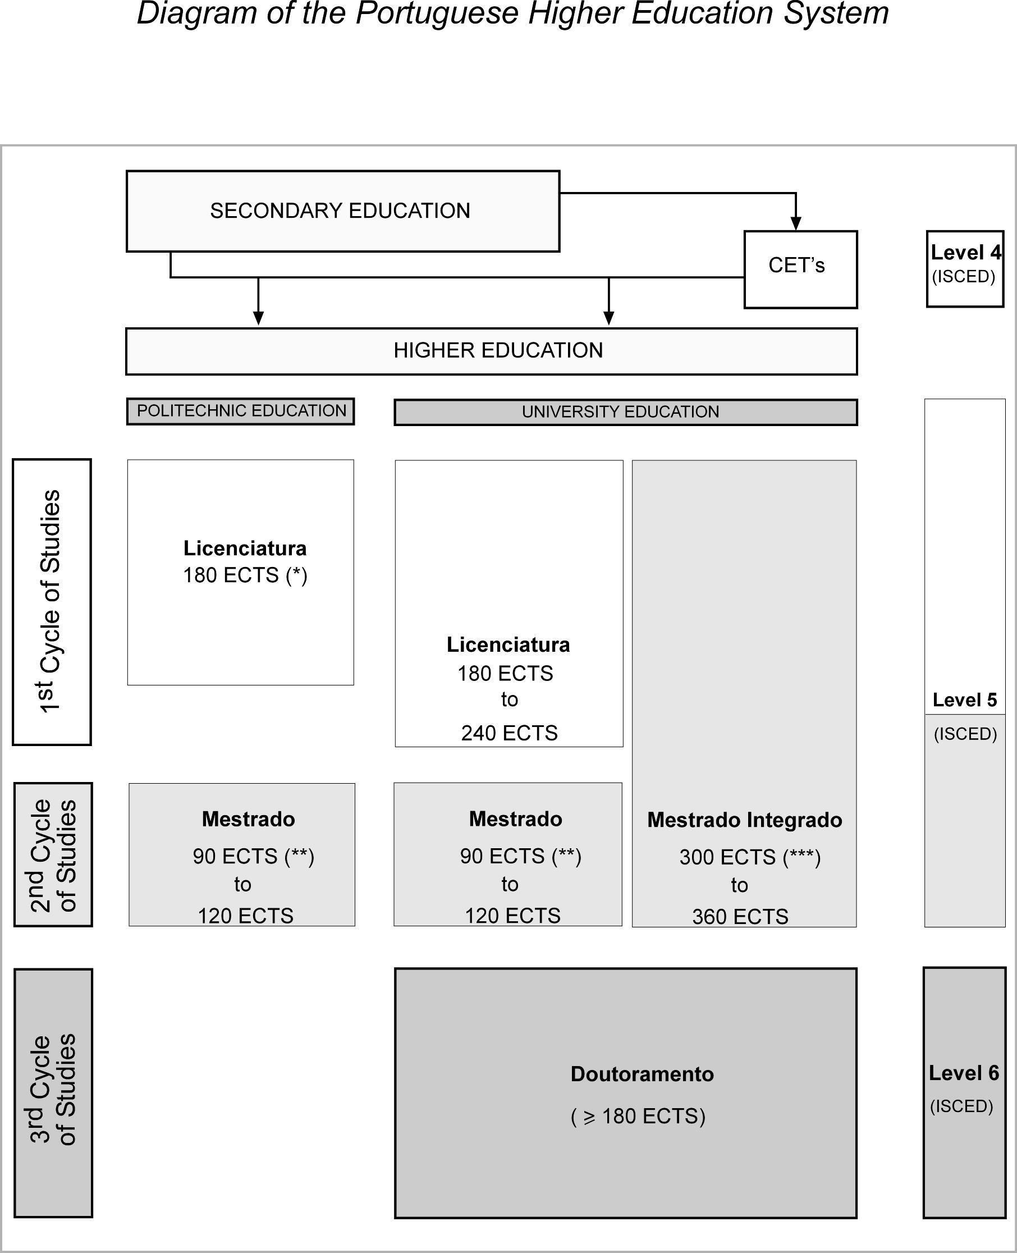

SOURCE: NARIC

(*) Except when in order to exercise a certain professional activity requiring education and training rating between 210 and 240 ECTS.
(**) In exceptional circumstances, and subject to the fulfillment of every requirement relating to the definition of the objectives of the degree and the conditions for acquiring the latter, a cycle of studies leading to a Mestre degree in a specialized field may be amount 60 credits resulting from a stable and consolidated practice in the specific field at international level.
(***) A Mestre degree may also be granted following and integrated cycle of studies of which the duration, for the purposes of obtaining access to a Professional activity, a) is established by European Union regulation; and b) results from a regular and consolidated practice within the European Union; in such cases, a Licenciado degree is granted to students having obtained 180 ECTS (3 years, 6 semesters).

